#What'sInMyCity
Analysis Document Final Submission

Group 7



Produced by the developers of #WhatsInMyCity

Gaitate NA, 31711820
Khumalo Ms, 40862208
Meyer CA, 45284644
Ramavhona T, 30397278

Table of Contents
1. Scope From Previous Phases 2
2. Physical Data Model 3
3. Physical Process Models 4
4. Database Schema 9
5. All SQL USED 9
6. Maintaining A Child Entity 15
7. Reports Generated By The System 16
8. User Manual 17
9. Screenshots Of Program 19
10. Detail Diary 28
11. ChatBot 28
12. Github Repository 30

Scope From Previous Phases

# | Scope Item | Description
1 | Maintain User Accounts | Create, update, and delete user profiles including credentials and personal information.
2 | Maintain Secure Documentation | Store and manage government-issued ID and passport information with OCR verification.
3 | Maintain Travel Passes | Create and manage QR-coded travel passes for transport and government affiliated venues.
4 | Maintain Bookings | Manage bookings for transport services and tourist attractions including availability checks.
5 | Provide Recommendations | Generate personalised tourist destination recommendations based on price, safety, and location.
6 | Store and Manage Payment  Information | Securely store payment card details and process transactions.

Physical Data Model

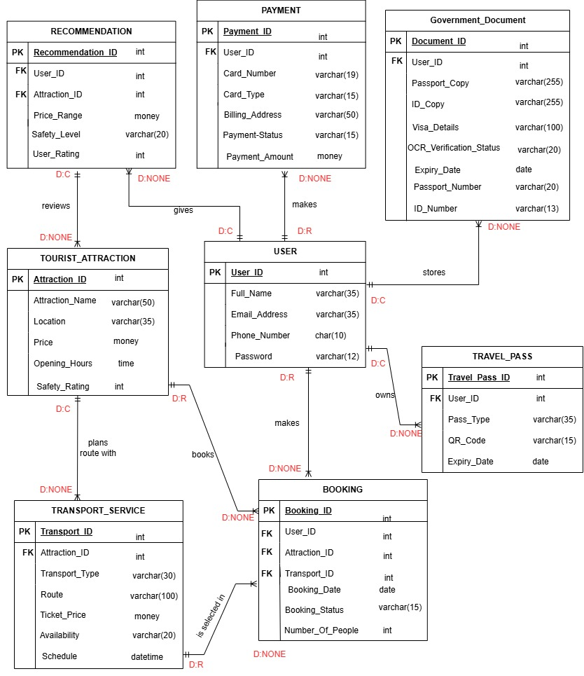

Physical Process Models

Create Tourist Booking

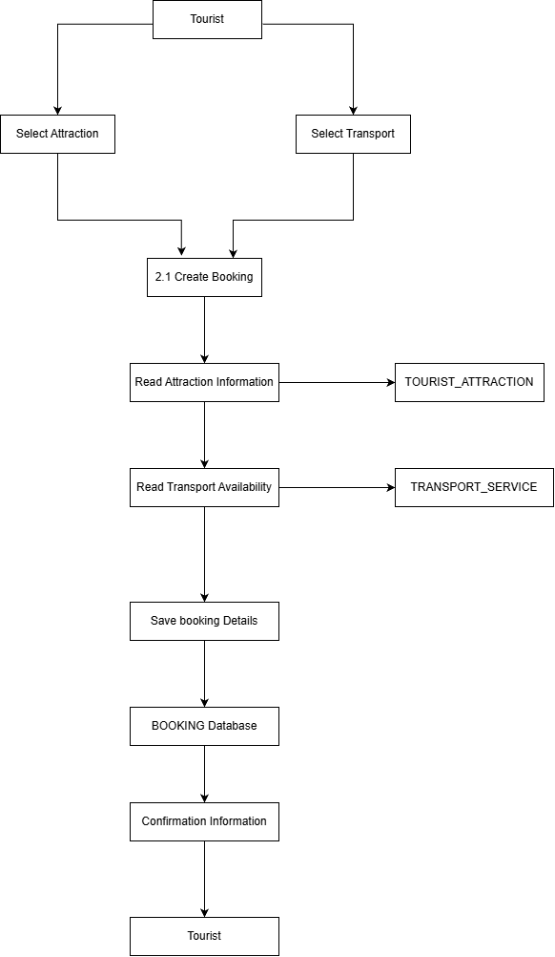

Process Payments
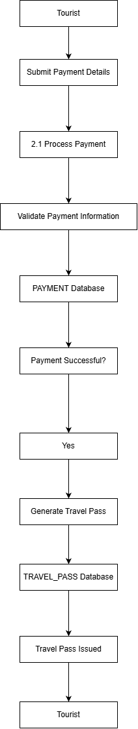

Maintain Transport Services
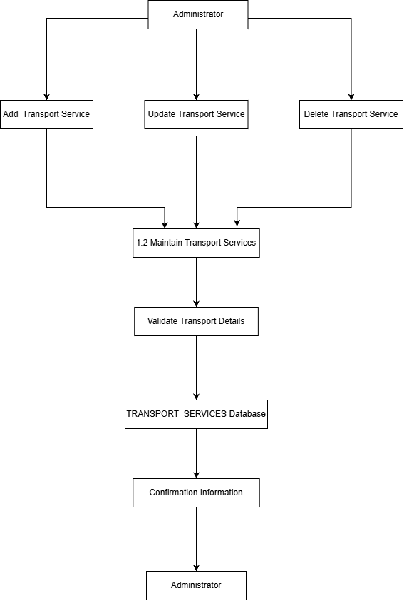

Maintain Tourist Attraction
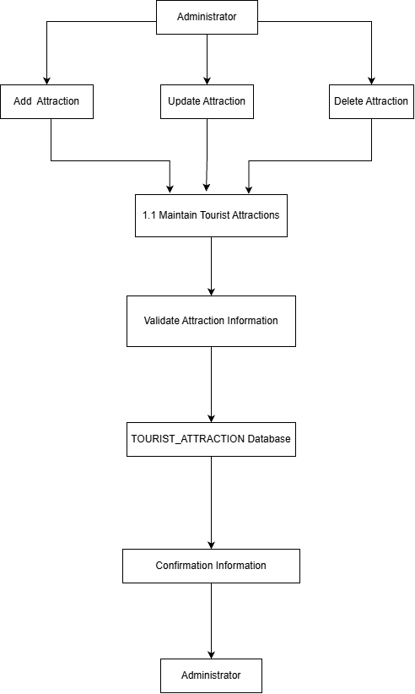

Database Schema
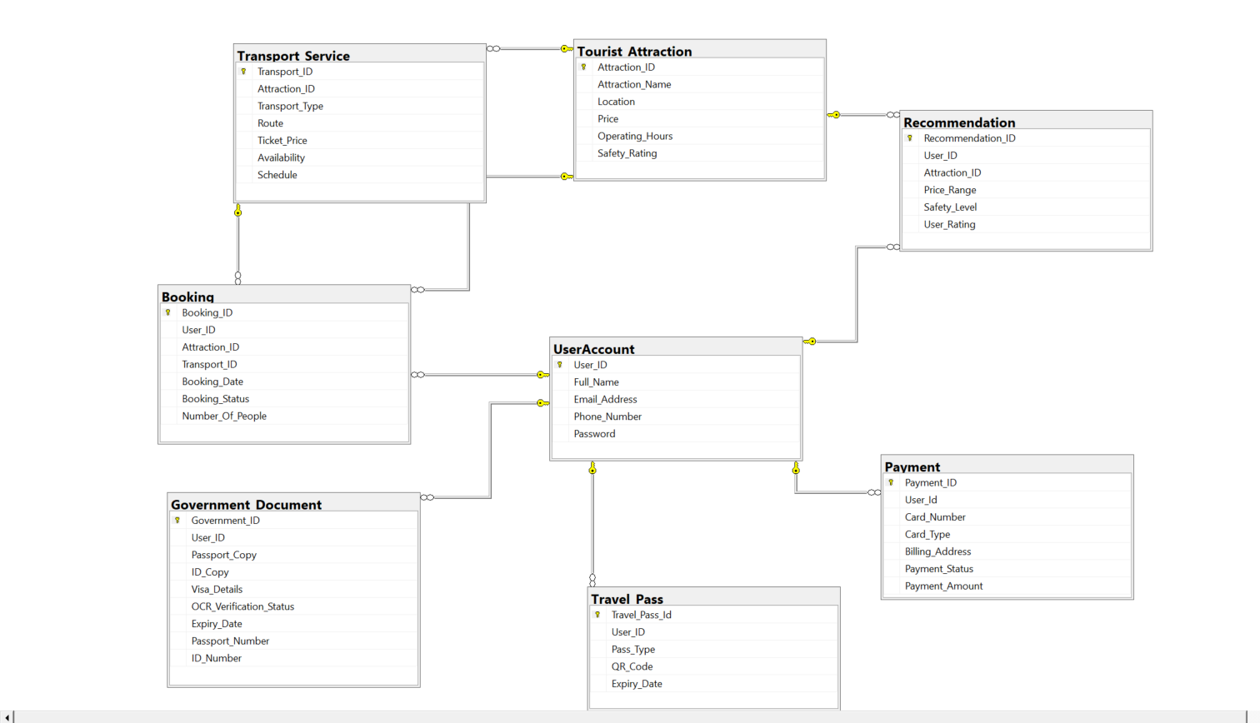

All SQL USED

Creating The Database:
UserAccount:
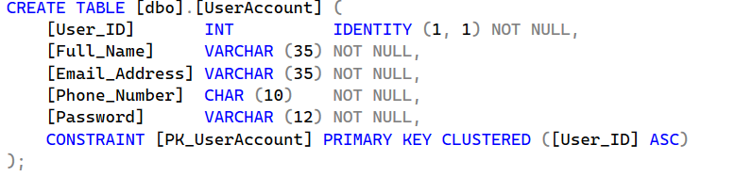

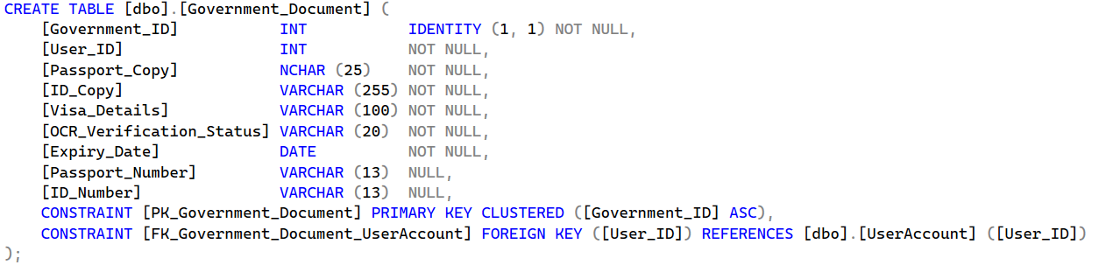
Government Document:
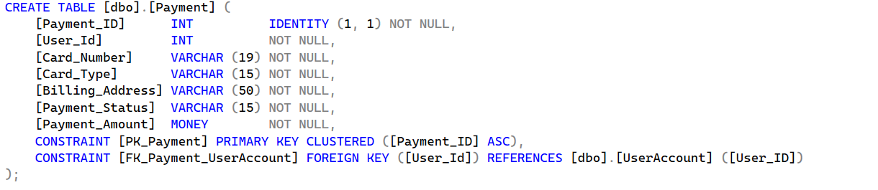
Payment:

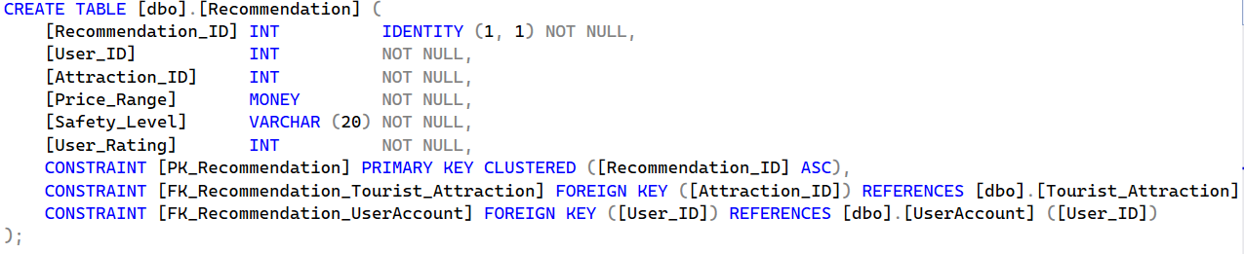
Recommendation:

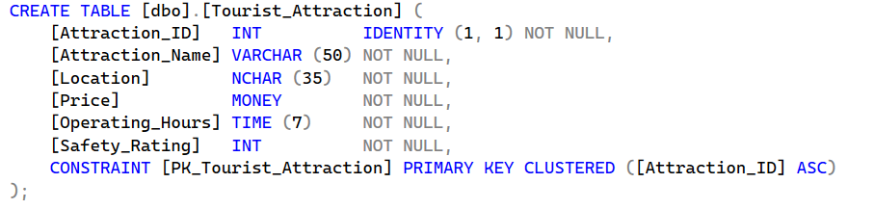
Tourist Attraction:

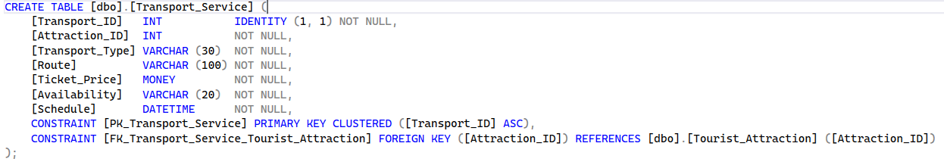
Transport Service:
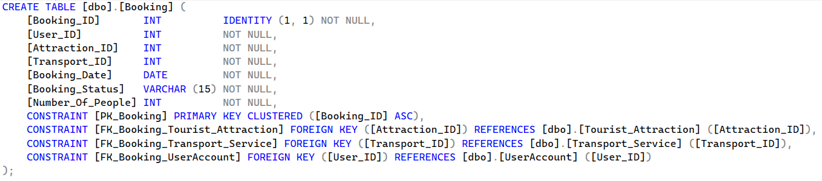
Booking:

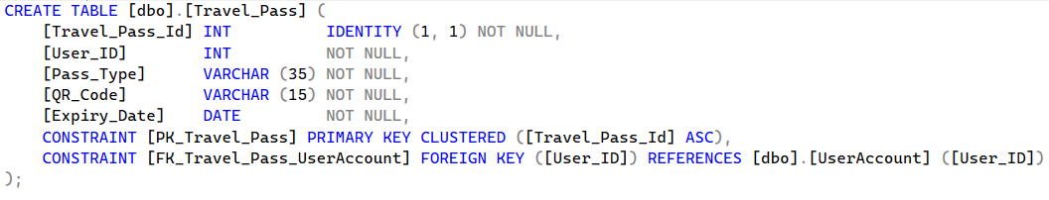
Travel Pass:
Maintaining The Database
Login Form:
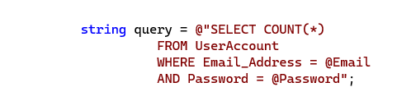

Register Form:
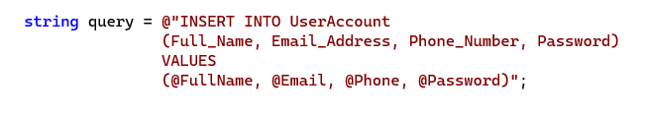

Insert Booking:
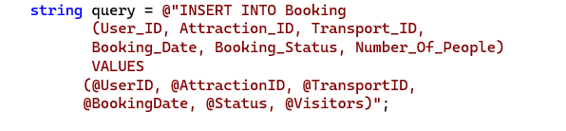

Update Booking:
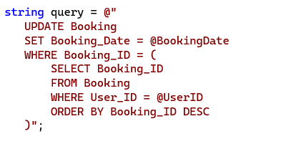

Cancel Booking:
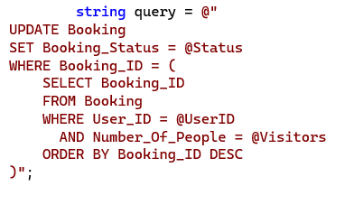

Load All Attractions:

Filter Attraction by Location:

User Profile Form:
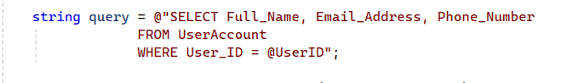

Insert in Government Document:

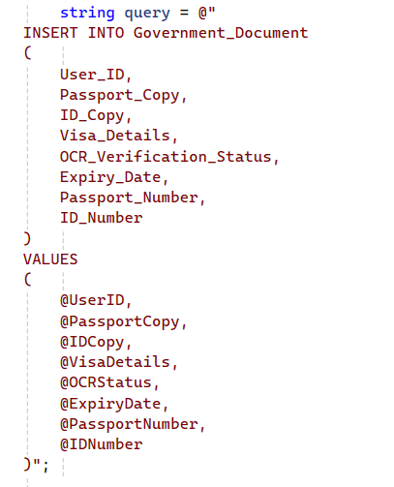

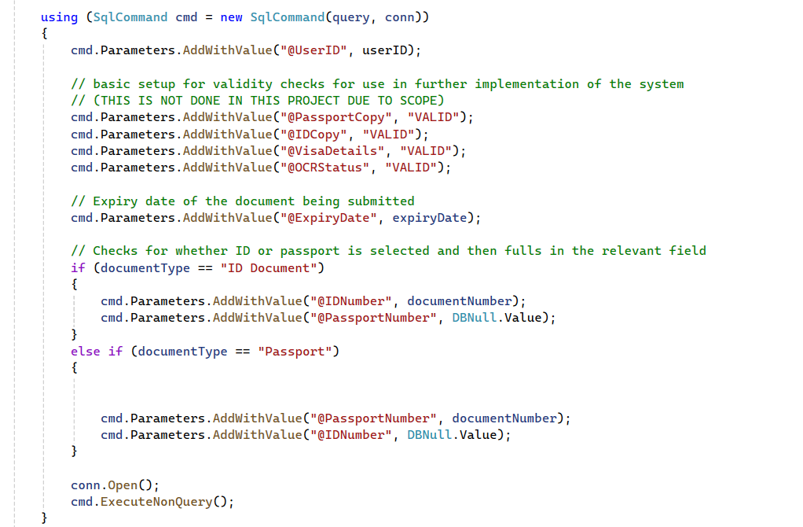

Travel Pass Form:

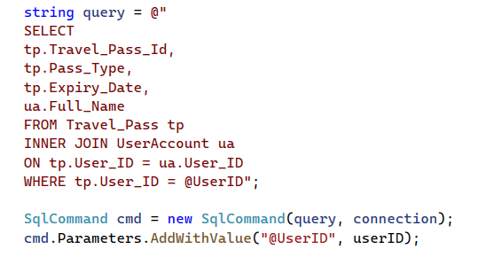

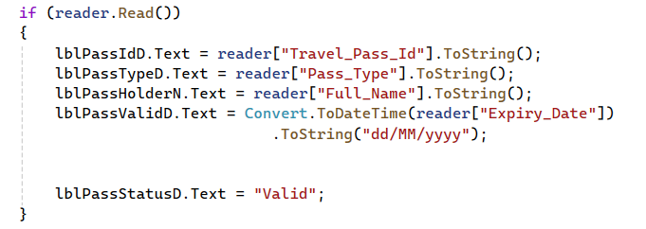

Maintaining A Child Entity

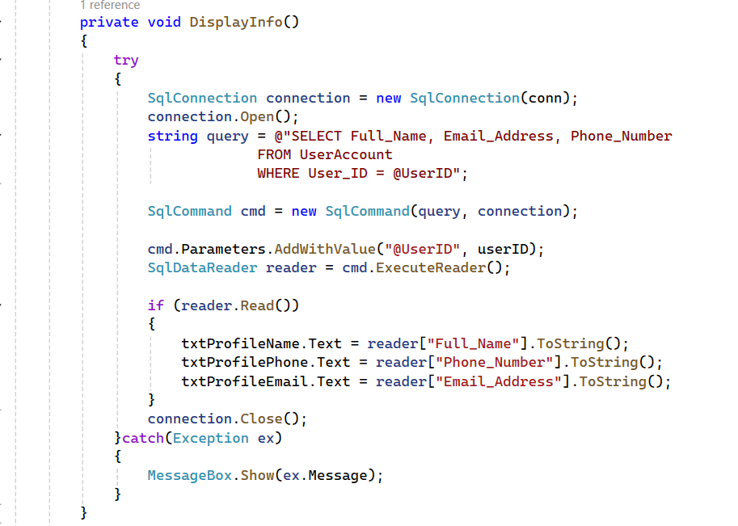

Reports Generated By The System

Report Generated to filter attractions (no filter for this image)
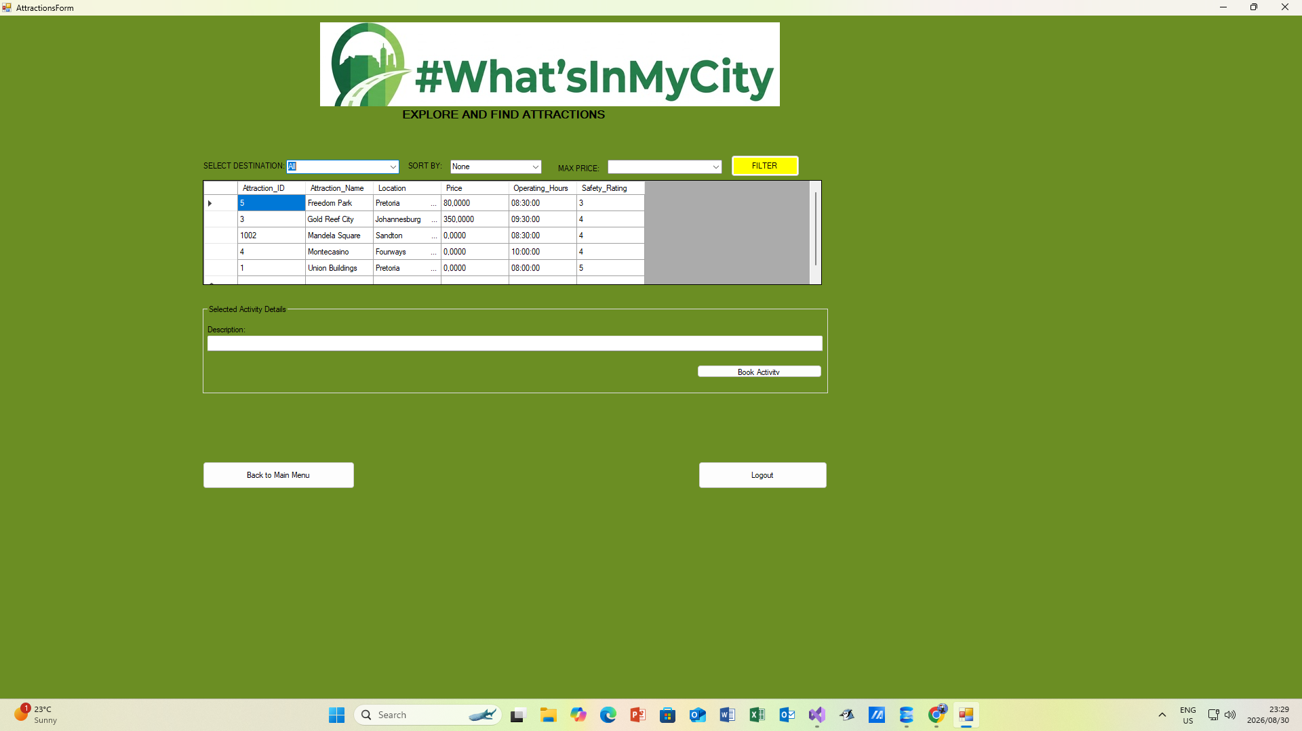

Report Generated With Filtered Attractions (To show Destination Fourways)
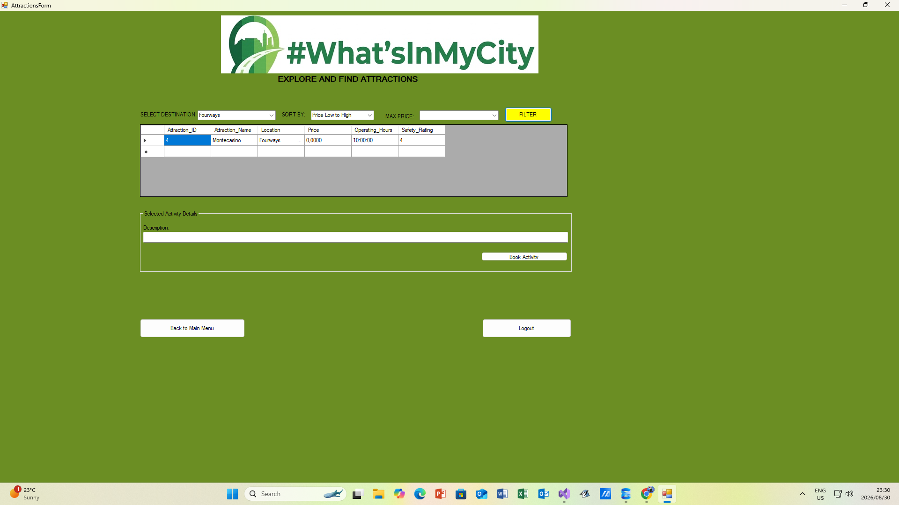

User Manual

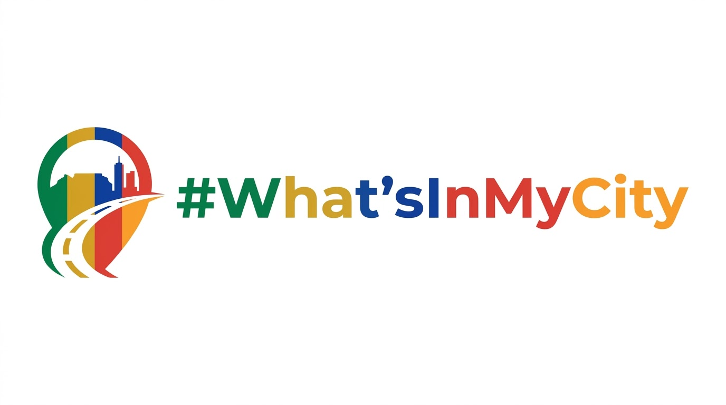

#WHATSINMYCITY
USER MANUAL

By The #WhatsInMyCity Development Team
Gaitate NA, 31711820
Khumalo Ms, 40862208
Meyer CA, 45284644
Ramavhona T, 30397278

1)Technical Requirements
- Minimum of 4 GB RAM
- Minimum processor speed of 1.6 GHz
- Stable internet connection
- 200 MB free HDD space
- Minimum screen resolution of 1366 x 768
- Windows 10 or 11 operating system
- Visual Studio code.

2) Getting started
- Download and install visual studio code with the .Net desktop development workload.
- Download whatsinmycity desktop application.
- Double-click the downloaded file to start the installation.
- Choose the folder where you want to save the application.
- When installation is complete, a desktop shortcut will be created on your desktop.

- Launching the application

- Double-click the desktop shortcut to open the application.
- The login page will appear first.
- Create an account or login to get started.
- Search for tourist attractions and transport services.
- Make bookings and receive a QR travel pass.

END OF USER MANUAL

Screenshots Of Program

Main Screen:
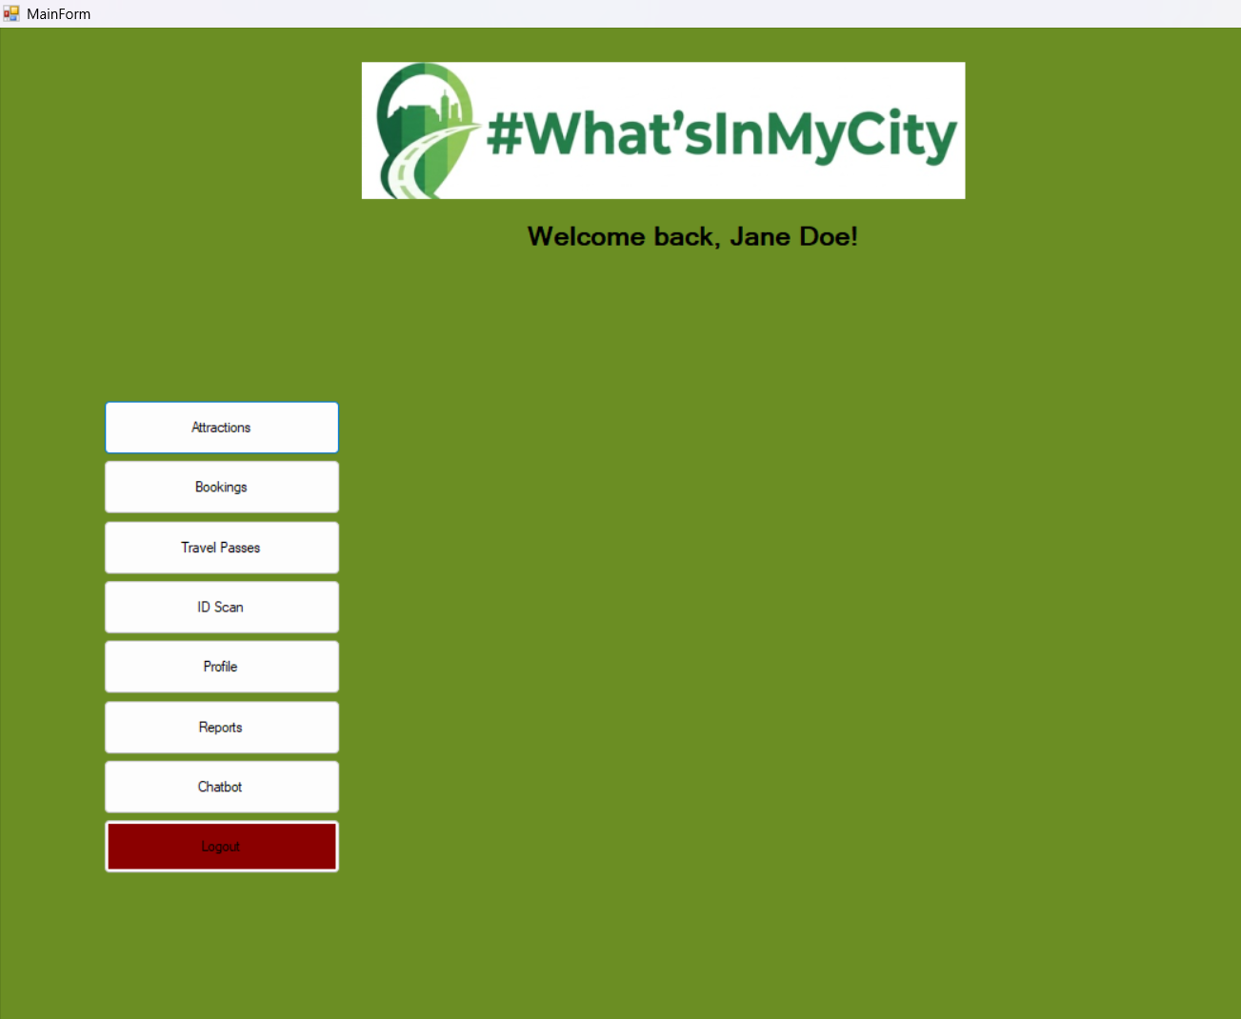

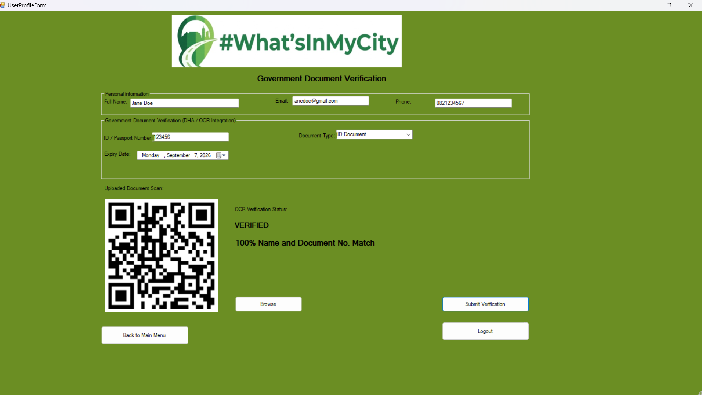
Loading Government Document:

Database Of Government Documents:

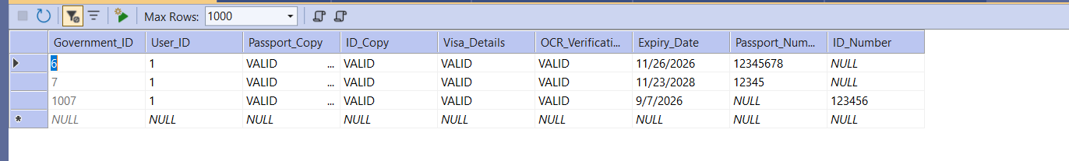

Showing Travel Pass And QR Code:
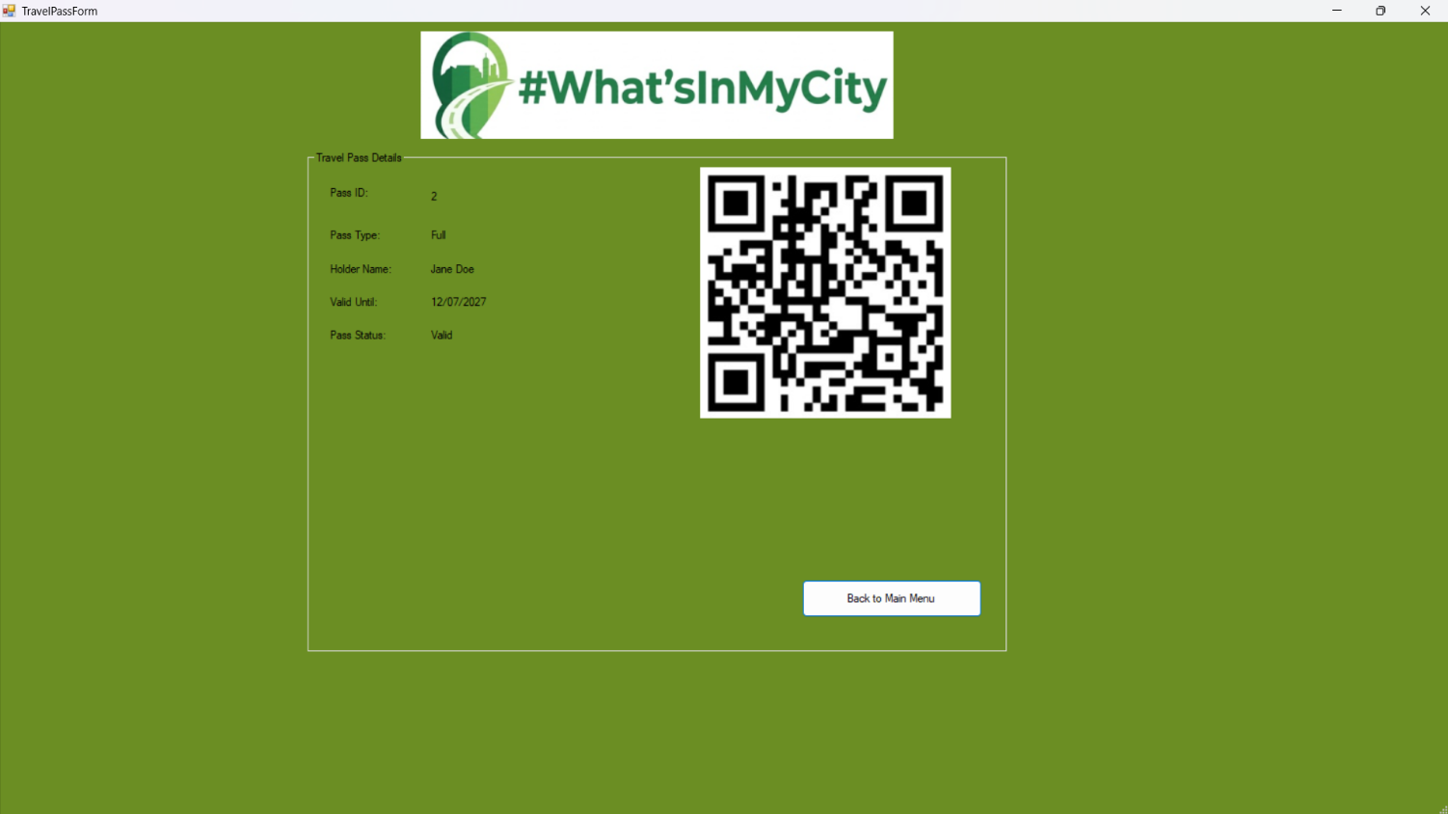

Database Entry Of The Above Travel Pass:

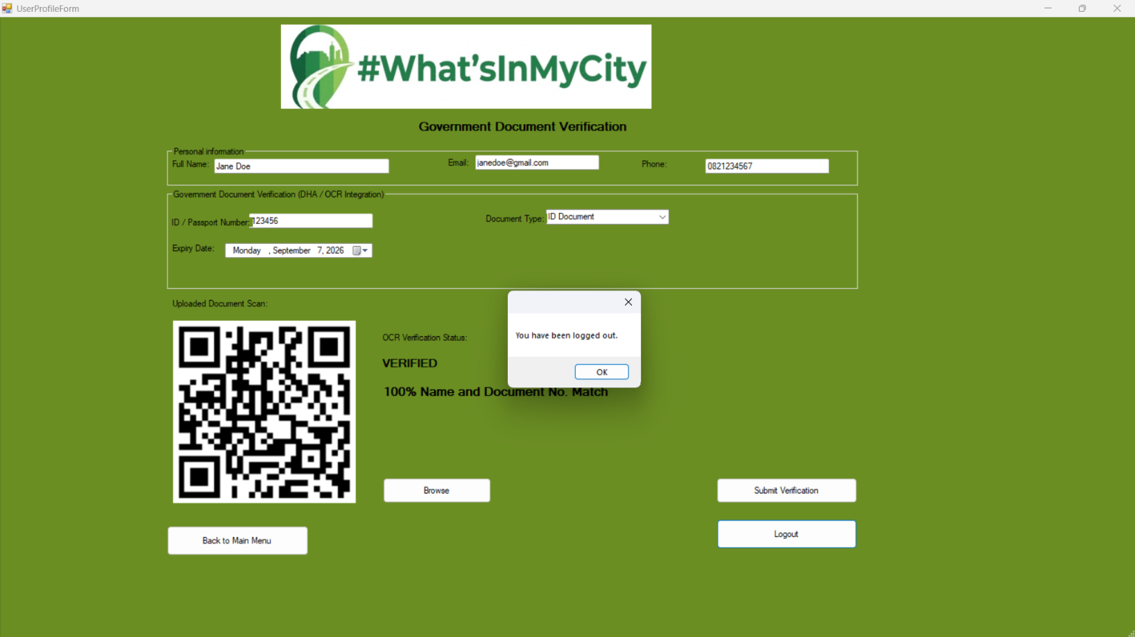
Logging Out:
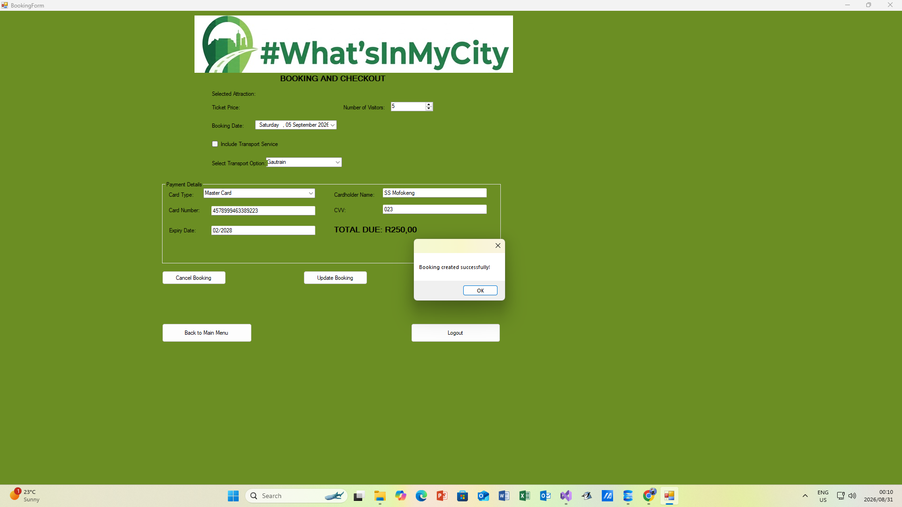
Creating Booking:

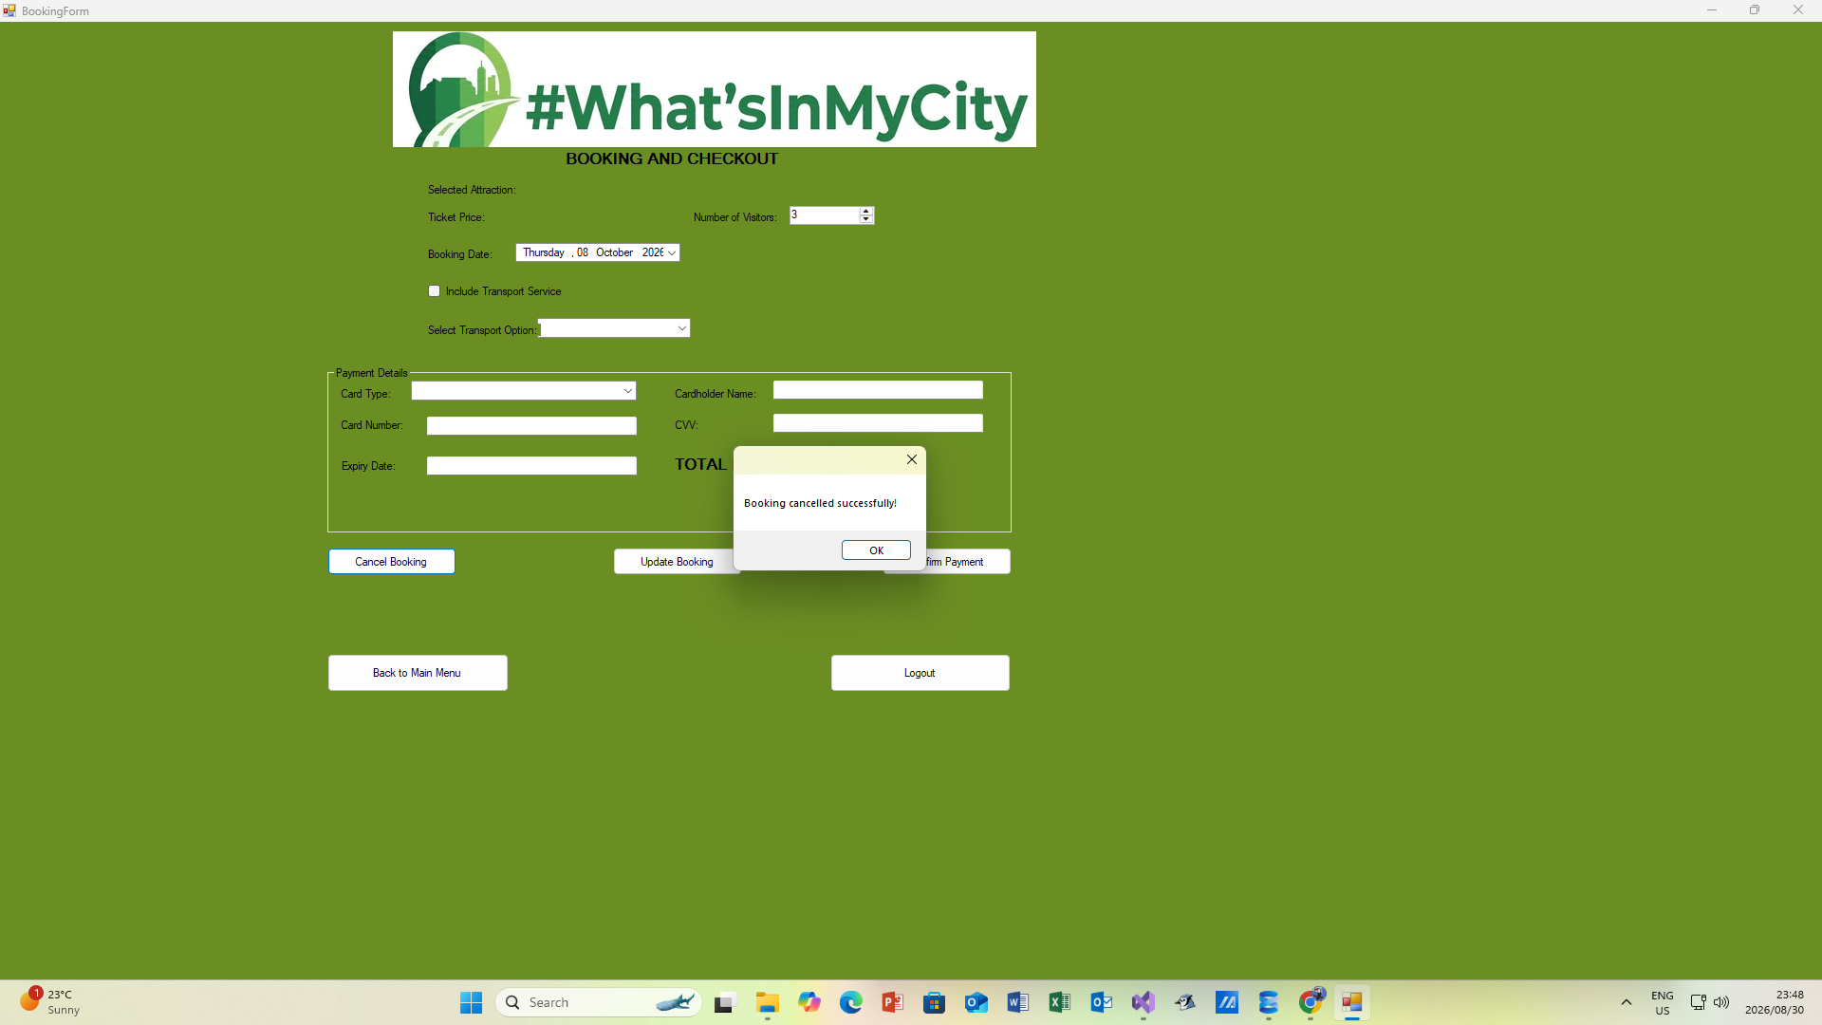
Cancelling Booking:
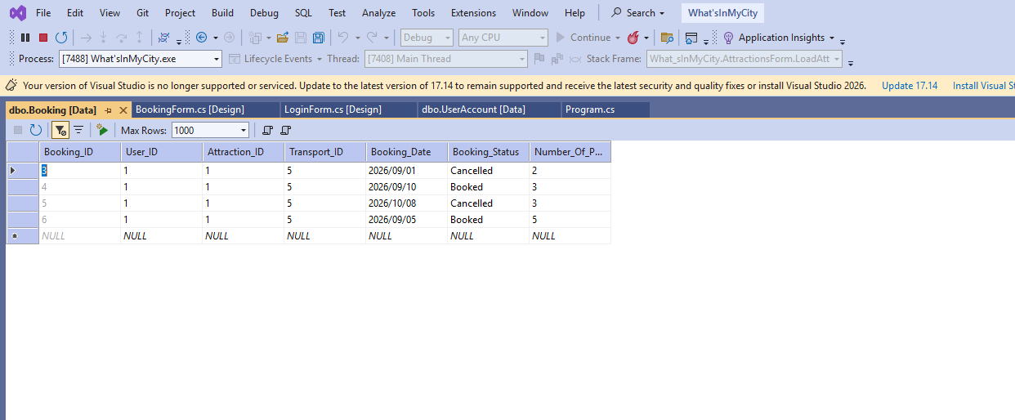
Booking Database:

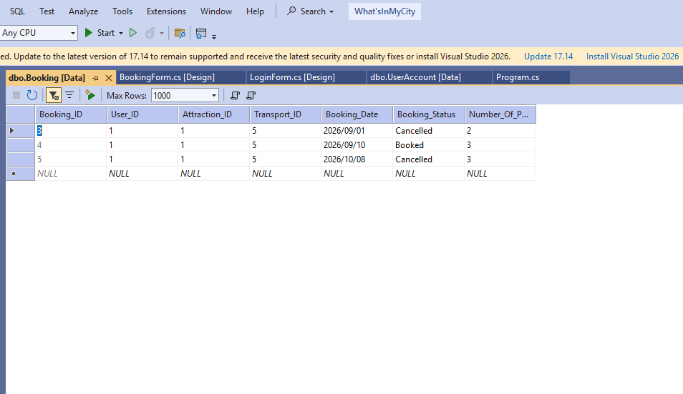
Cancelled Booking Database:

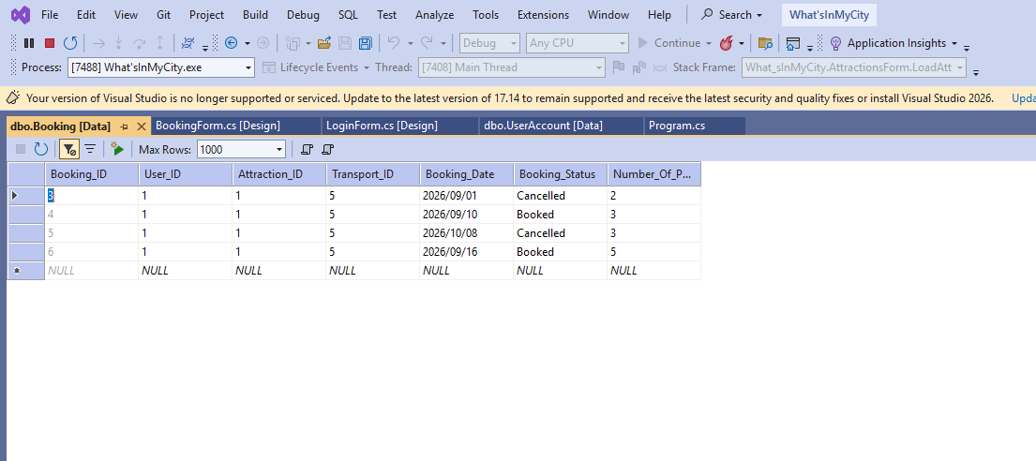
Update Booking Database:

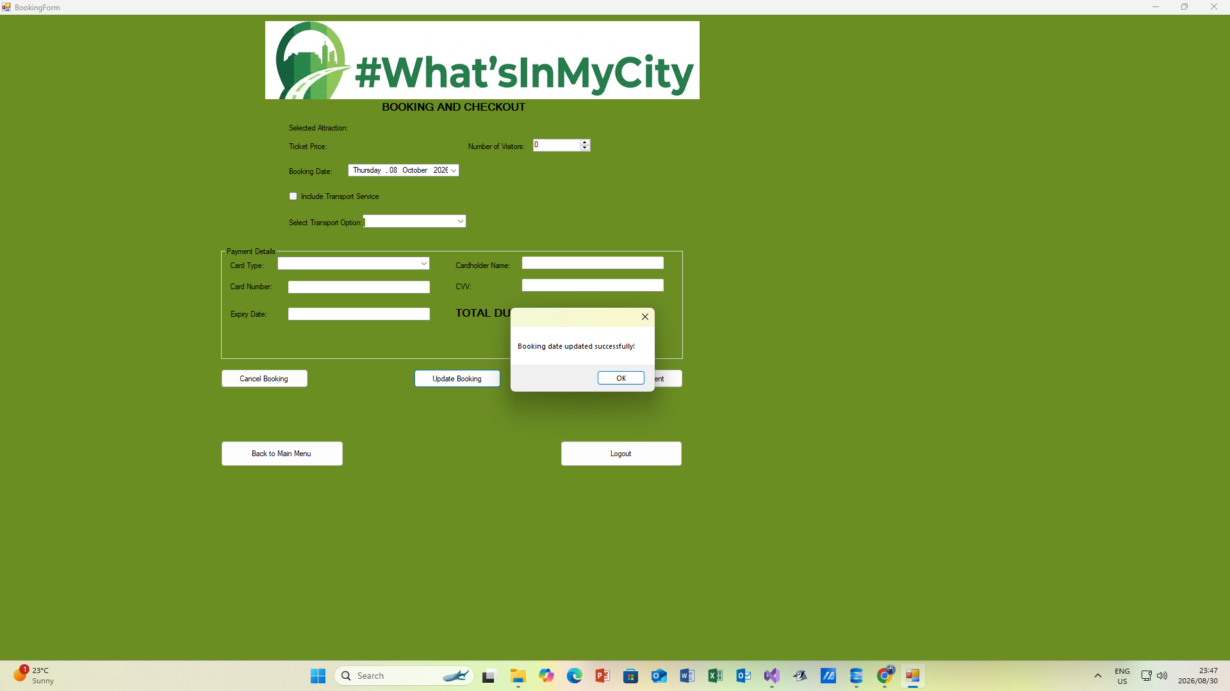
Update Booking:


Load All Attractions:
Filter Attractions:

Testing Signup: 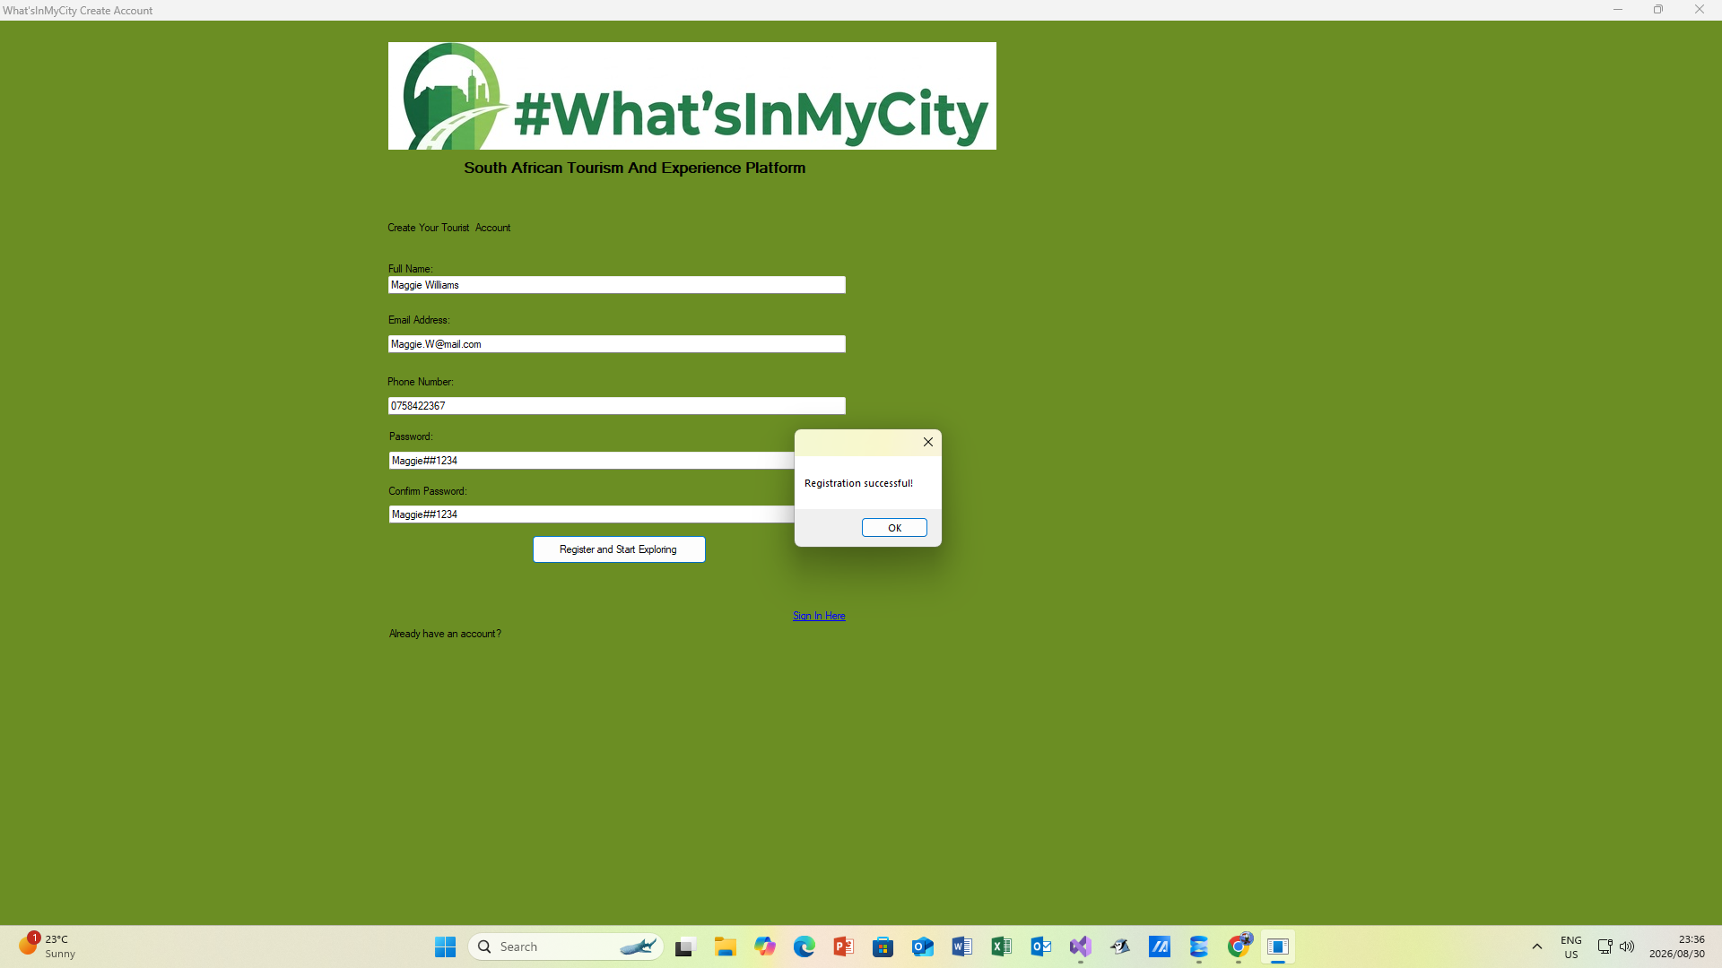
Testing Signup Database:
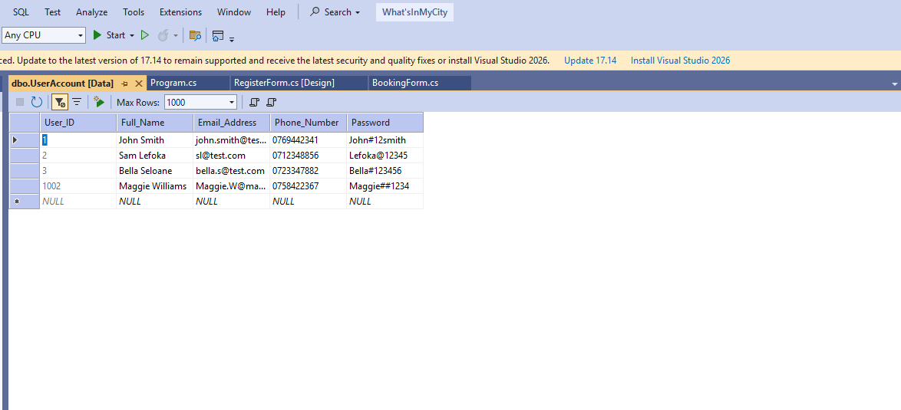
Testing Login:
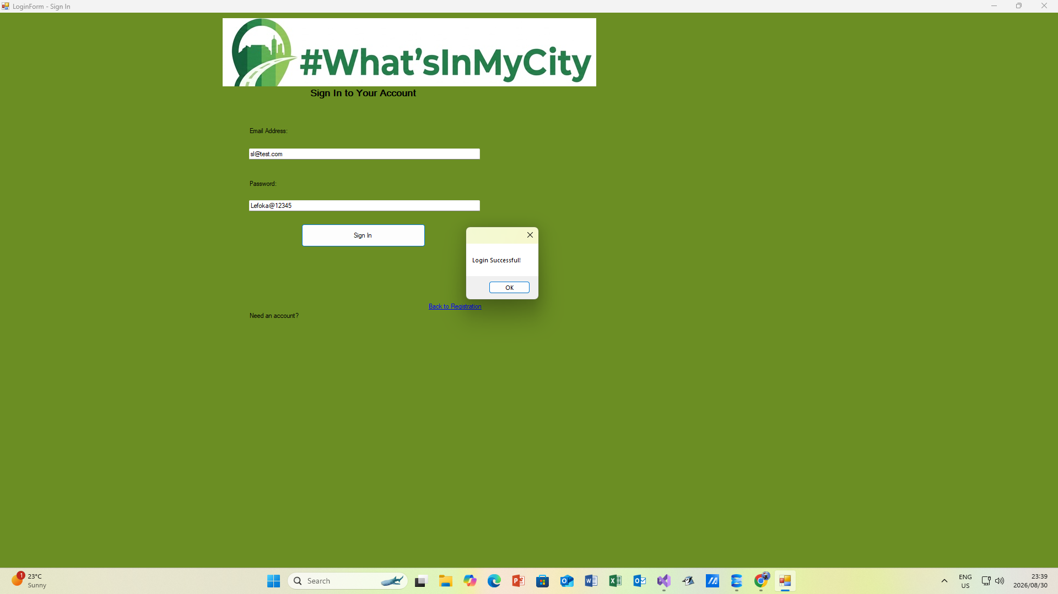

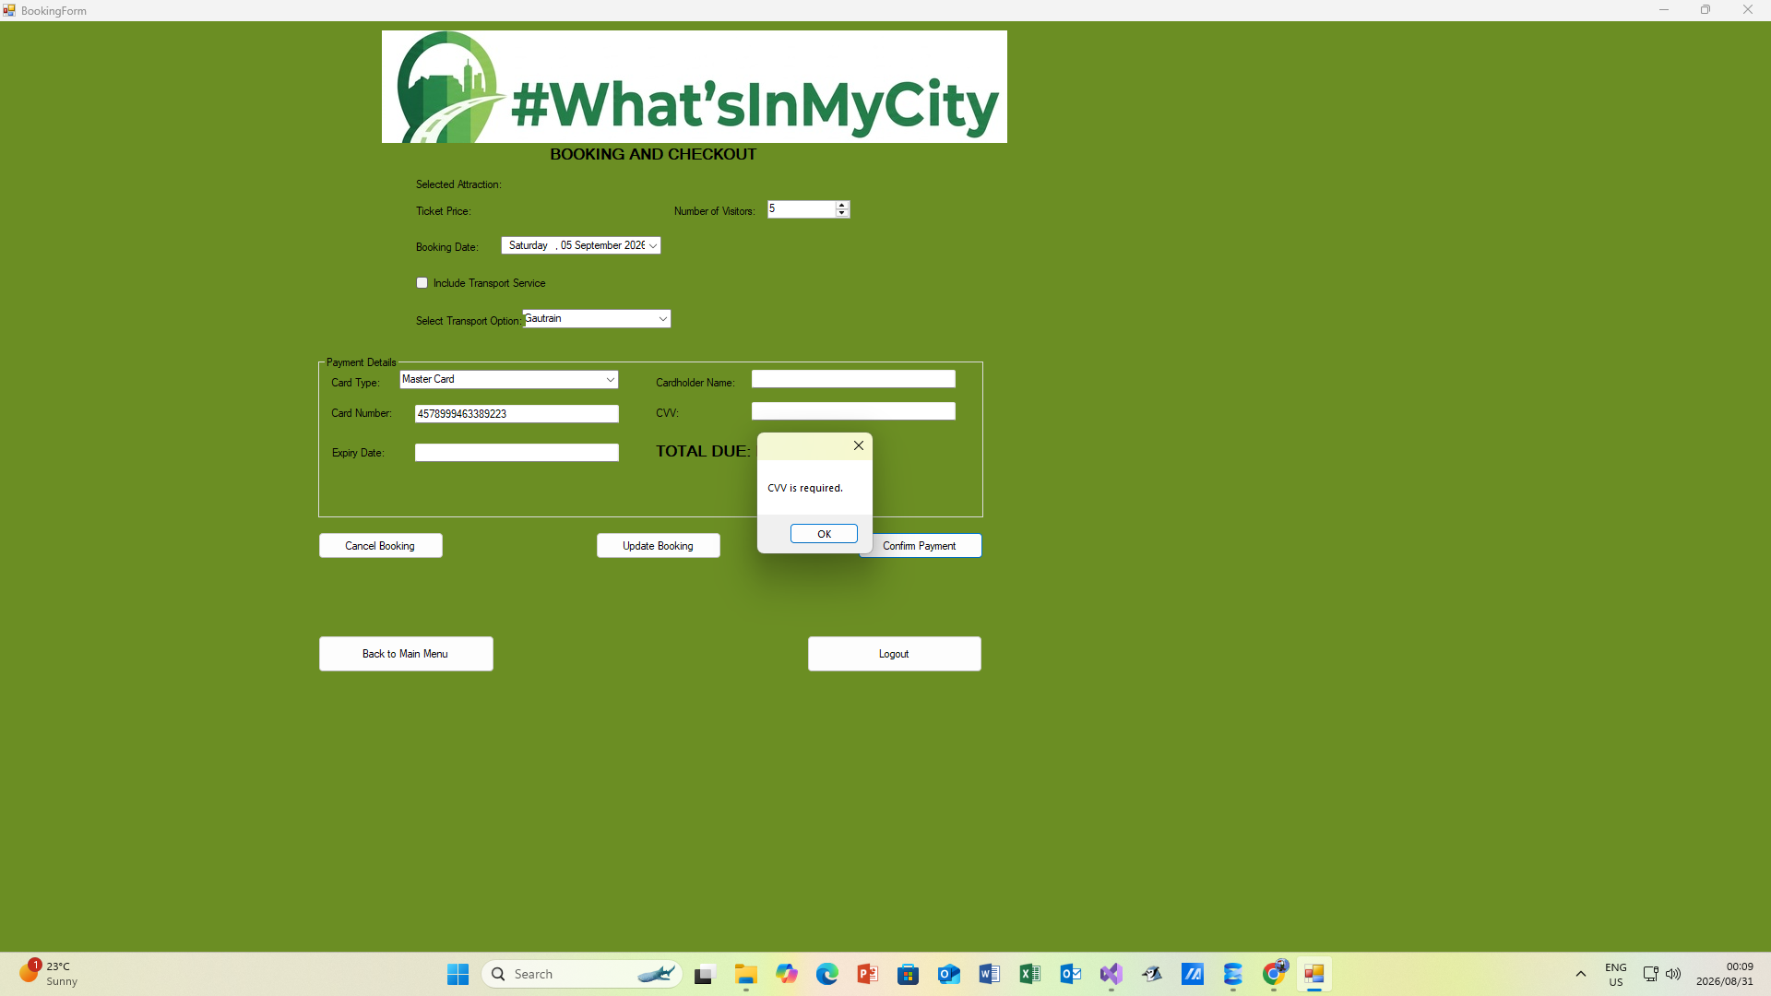
Validation Of Card:

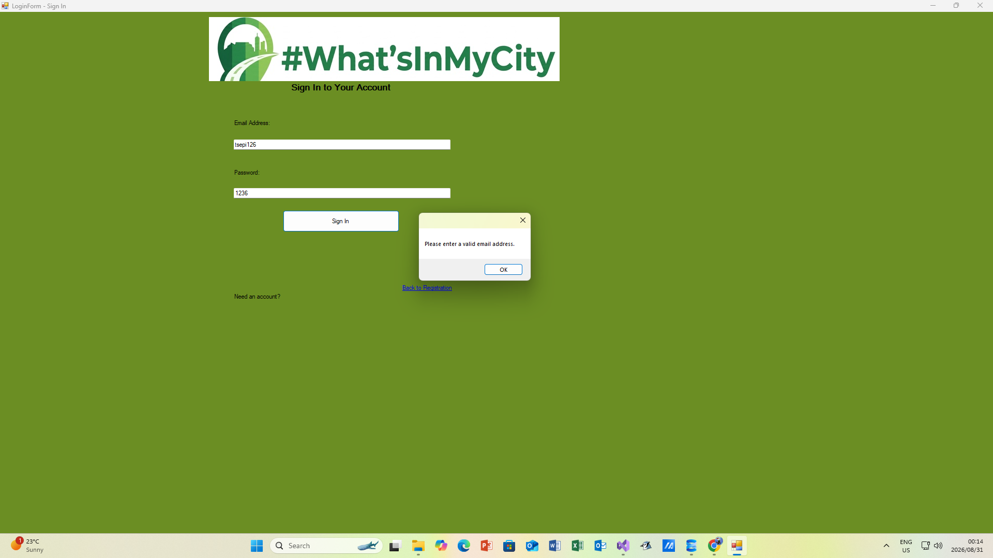
Validation Of Email:

Detail Diary
Listed below is all of the logged times and work done by the developers of #WhatsInMyCity. Please note that Github dates may vary due to the use of different branches and pull requests.
20 August 5pm- 6pm: All members attended meeting to discuss project
21 August 4pm – 9pm: Gaitate worked on Physical Data Model
21 August 5pm – 11pm: Khumalo worked on the ERD and SQL Schema
23 August 3pm – 7pm: Meyer worked on the Physical Process Models
24 August 2pm – 6pm: Ramavhona worked on the frontend UI
25 August 2pm – 6pm: Ramavhona worked on the frontend (Continued)
27 August 2pm – 5pm Ramavhona worked on the frontend (finished)
27 August 3pm – 5pm Khumalo set up the full Github repository
28 August 4pm – 11pm Meyer worked on backend code
28 August 5pm- 12am Gaitate worked on backend code
29 August 3pm – 7pm Khumalo worked on the Chatbot
30 August 10am – 2pm Meyer worked on Presentation
30 August 10am – 3pm Gaitate worked on the User Manual
31 August 2pm – 5pm Ramavhona worked on error handling on frontend
1 September 2pm – 8pm Meyer worked on presentation and video
2 September 3pm – 5pm Team dd full check of project and were ready for submission.

ChatBot

Please refer to the presentation to see the chatbot in action as images don’t really do it much justice. However as a bit of insight here is a snippet from the code on the next page.

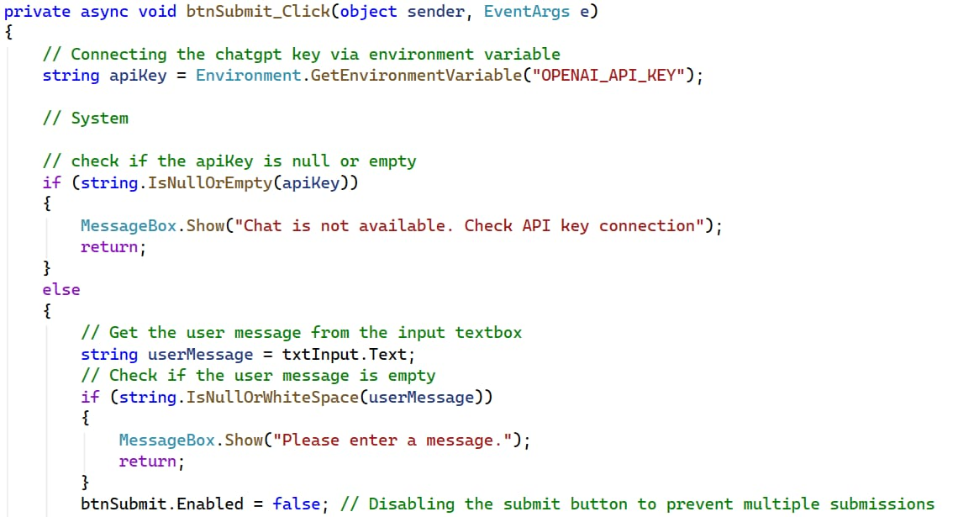
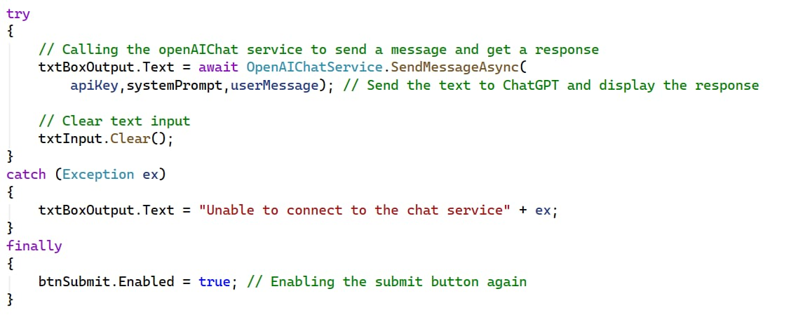
And some more code

Github Repository
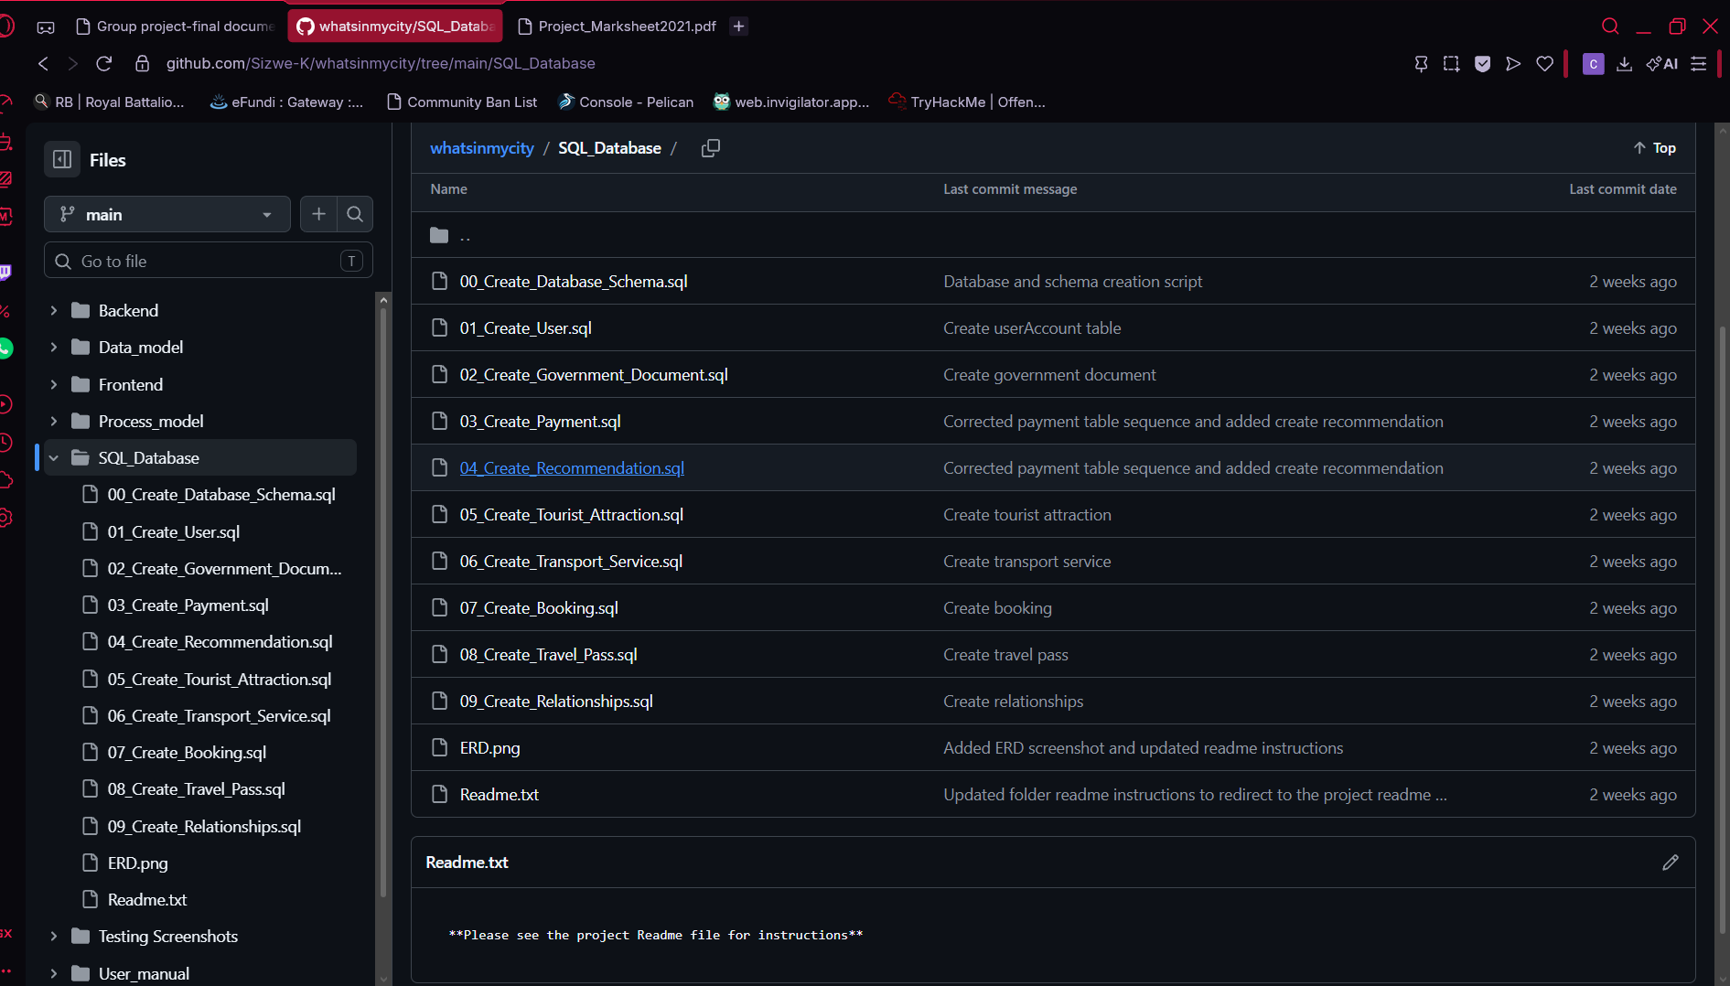
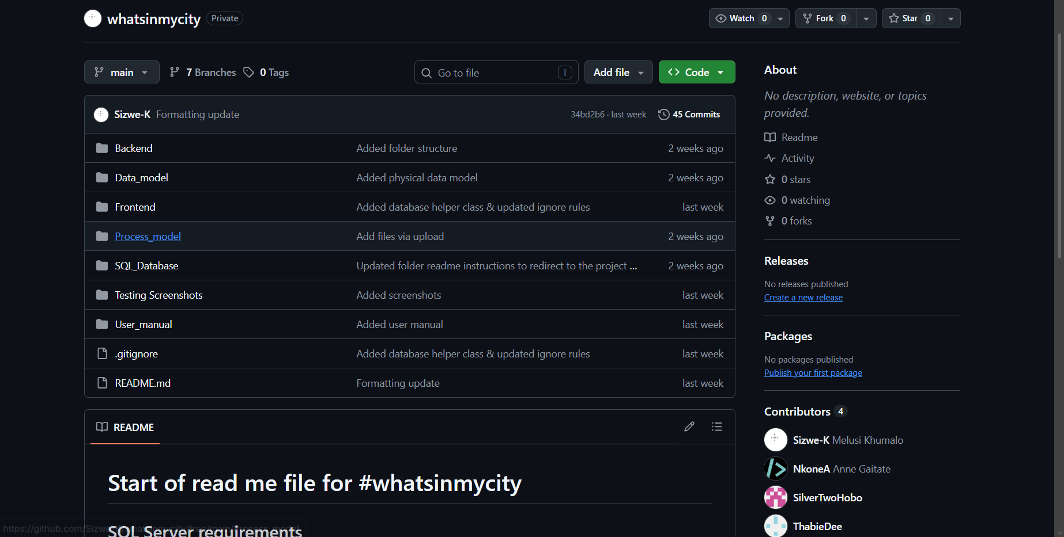

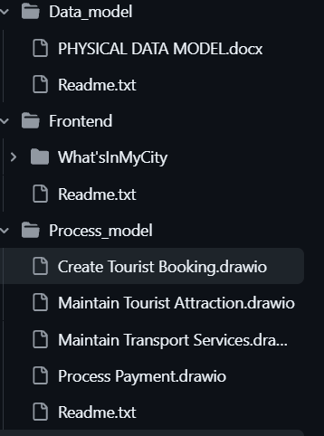
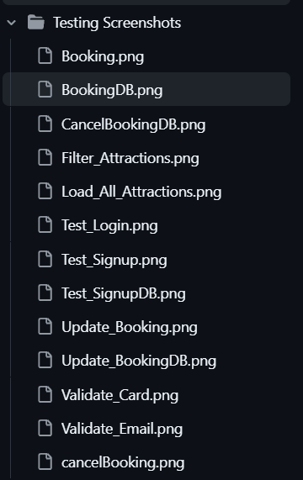

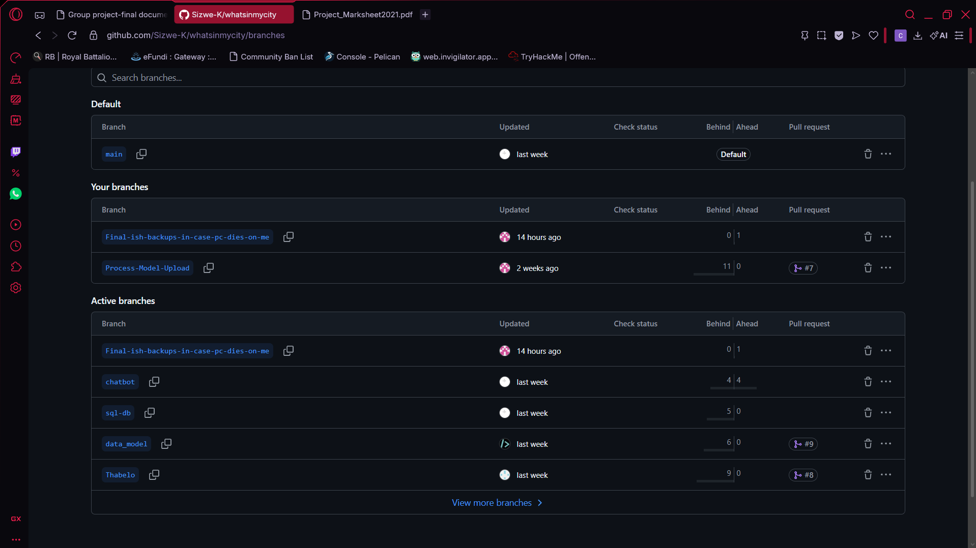

Above is the Github that we used for the project, while all items are not in the screenshot for QOL reasons, I have added a screenshot of all of our current branches included in the project that all run off of separate commits to main to avoid clashes.

********************************************************************************************************

